**[2024-2025]**

CERTIFICATE

This is to certify that *Yuvraj Singh, Ashwinder, and Madhav Gupta* of class XII has successfully completed the project of Library Management System according to CBSE guidelines under my guidance and supervision during the academic year 2024-2025

Mr. Benoie Mathew External Examiner

Head of the department

(Department of Computer Science)

ACKNOWLEDGEMENT

I would like to express my special thanks to my Informatics Practice teacher **Mr. Benoie Mathew**, who gave me the golden opportunity to do this wonderful project of Informatics Practices on the topic **“Library Management”** and helped me a lot in completing this project. I came to know so many things and I’m genuinely thankful to him. I am also deeply grateful to my principal, **Ms. Nidhi Jain**, for her constant encouragement and for allowing me to use the school’s advanced computer labs, which greatly facilitated my work on this project. Secondly, I would like to thank my parents and friends who helped me a lot in finalizing this project within the limited time frame.

Board Roll No:

INDEX

|  |  |
| --- | --- |
| **Content** | **Page No.** |
| 1. Introduction | - |
| * + Problem Definition | 05 |
| * + Python Introduction | 06 |
| * + MySQL Introduction | 07 |
| 1. About Program | 08 |
| 1. System Requirements | - |
| * Software Requirements | 09 |
| * Hardware Requirements | 09 |
| 1. Table design | 10 |
| 1. Preview Of Program | 12 |
| 1. References | - |
| * Bibliography | 22 |
| * Webliography | 22 |

Introduction

* PROBLEM DEFINITION

Libraries are essential institutions that provide access to knowledge and resources, serving as a cornerstone for education and information dissemination. However, managing library operations effectively remains a significant challenge, especially in large-scale or resource-constrained environments.

Traditional methods of maintaining library records—such as manually tracking books, borrowers, and transactions—are often labor-intensive and prone to errors. These inefficiencies can result in mismanagement of resources, difficulties in locating specific books, and delays in tracking borrowed items or overdue returns. Moreover, without a proper system in place, maintaining transparency and accountability becomes a daunting task.

As the demand for library services grows, manual processes struggle to keep up. Librarians may face difficulties such as:

* Inconsistent or inaccurate record-keeping.
* Limited visibility into the availability of books and overdue returns.
* Challenges in managing a growing inventory and user base.
* Lack of security in accessing sensitive information, leading to potential misuse or data loss.

Furthermore, without a structured system, borrowers may face inconvenience in accessing resources or understanding their responsibilities, such as return deadlines or overdue fines.

These issues highlight the urgent need for a streamlined approach to library management, one that minimizes errors, optimizes resource utilization, and enhances both librarian and user experience.



* PYTHON INTRODUCTION

**PYTHON HISTORY:** Python was conceived in the late 1980s by [Guido Van](https://en.wikipedia.org/wiki/Guido_van_Rossum) [Rossum](https://en.wikipedia.org/wiki/Guido_van_Rossum) at [Centrum Wiskunde & Informatica](https://en.wikipedia.org/wiki/Centrum_Wiskunde_%26_Informatica) (CWI) in the [Netherlands](https://en.wikipedia.org/wiki/Netherlands) as a successor to the [ABC programming language](https://en.wikipedia.org/wiki/ABC_(programming_language)), which was inspired by [SETL](https://en.wikipedia.org/wiki/SETL), capable of [exception](https://en.wikipedia.org/wiki/Exception_handling) [handling](https://en.wikipedia.org/wiki/Exception_handling) (from the start plus new capabilities in Python 3.11) and interfacing with the [Amoeba](https://en.wikipedia.org/wiki/Amoeba_(operating_system)) operating system. Its implementation began in December 1989. Van Rossum shouldered sole responsibility for the project, as the lead developer, until 12 July 2018, when he announced his "permanent vacation" from his responsibilities as Python's "[benevolent](https://en.wikipedia.org/wiki/Benevolent_dictator_for_life) [dictator for life](https://en.wikipedia.org/wiki/Benevolent_dictator_for_life)", a title the Python community bestowed upon him to reflect his long-term commitment as the project's chief decision-maker. In January 2019, active Python core developers elected a five-member Steering Council to lead the project.

**PYTHON**: Python is a [multi-paradigm programming language.](https://en.wikipedia.org/wiki/Multi-paradigm_programming_language) [Object-oriented](https://en.wikipedia.org/wiki/Object-oriented_programming) [programming](https://en.wikipedia.org/wiki/Object-oriented_programming) and [structured programming](https://en.wikipedia.org/wiki/Structured_programming) are fully supported, and many of their features support functional programming and aspect-oriented [programming](https://en.wikipedia.org/wiki/Aspect-oriented_programming) (including [meta-programming](https://en.wikipedia.org/wiki/Metaprogramming) and [meta-objects](https://en.wikipedia.org/wiki/Metaobject)). Many other paradigms are supported via extensions, including [design by contract.](https://en.wikipedia.org/wiki/Design_by_contract) and [logic programming](https://en.wikipedia.org/wiki/Logic_programming).

Python uses [dynamic typing](https://en.wikipedia.org/wiki/Dynamic_typing) and a combination of [reference counting](https://en.wikipedia.org/wiki/Reference_counting) and a cycle-detecting garbage collector for [memory management.](https://en.wikipedia.org/wiki/Memory_management) It uses dynamic [name resolution](https://en.wikipedia.org/wiki/Name_resolution_(programming_languages)) ([late binding](https://en.wikipedia.org/wiki/Late_binding)), which binds method and variable names during program execution.

* SQL INTRODUCTION

**SQL HISTORY**: SQL was initially developed at [IBM](https://en.wikipedia.org/wiki/IBM) by [Donald D.](https://en.wikipedia.org/wiki/Donald_D._Chamberlin) [Chamberlin](https://en.wikipedia.org/wiki/Donald_D._Chamberlin) and [Raymond F. Boyce](https://en.wikipedia.org/wiki/Raymond_F._Boyce) after learning about the relational model from [Edgar F.](https://en.wikipedia.org/wiki/Edgar_F._Codd) [Codd](https://en.wikipedia.org/wiki/Edgar_F._Codd) in the early 1970s. This version, initially called SEQUEL (Structured English Query Language), was designed to manipulate and retrieve data stored in IBM's original quasirelational database management system, [System R](https://en.wikipedia.org/wiki/IBM_System_R), which a group at [IBM San Jose](https://en.wikipedia.org/wiki/IBM_Almaden_Research_Center) [Research Laboratory](https://en.wikipedia.org/wiki/IBM_Almaden_Research_Center) had developed during the 1970s.

Chamberlin and Boyce's first attempt at a relational database language was SQUARE (Specifying Queries in A Relational Environment), but it was difficult to use due to subscript/superscript notation. After moving to the San Jose Research Laboratory in 1973, they began work on a sequel to SQUARE. The name SEQUEL was later changed to SQL (dropping the vowels) because "SEQUEL" was a [trademark](https://en.wikipedia.org/wiki/Trademark) of the [UK-based](https://en.wikipedia.org/wiki/United_Kingdom) [Hawker](https://en.wikipedia.org/wiki/Hawker_Siddeley) [Siddeley](https://en.wikipedia.org/wiki/Hawker_Siddeley) Dynamics Engineering Limited company. The label SQL later became the acronym for Structured Query Language.

**SQL** : **Structured Query Language**, abbreviated as **SQL** is a [domain-specific language](https://en.wikipedia.org/wiki/Domain-specific_language) used in programming and designed for managing data held in a [relational database management](https://en.wikipedia.org/wiki/Relational_database_management_system) [system](https://en.wikipedia.org/wiki/Relational_database_management_system) (RDBMS), or for stream processing in a [relational data stream management](https://en.wikipedia.org/wiki/Relational_data_stream_management_system) [system](https://en.wikipedia.org/wiki/Relational_data_stream_management_system) (RDSMS). It is particularly useful in handling [structured data,](https://en.wikipedia.org/wiki/Data_model) i.e. data incorporating relations among entities and variables.

SQL offers two main advantages over older read–write [APIs](https://en.wikipedia.org/wiki/API) such as [ISAM](https://en.wikipedia.org/wiki/ISAM) or [VSAM](https://en.wikipedia.org/wiki/VSAM). Firstly, it introduced the concept of accessing many records with one single command. Secondly, it eliminates the need to specify how to reach a record, e.g. with or without an [index](https://en.wikipedia.org/wiki/Database_index).

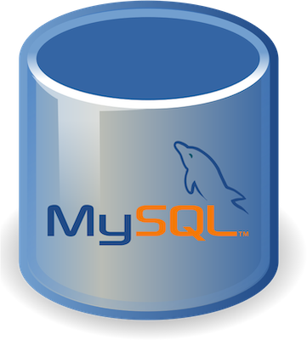ABOUT PROGRAM

This is a **Library Management System** designed to assist librarians in managing library operations with greater efficiency and ease. The system is tailored to function like a specialized operating system for library management, optimized to run on low hardware requirements compared to other solutions.

KEY FEATURES:

1. **Security**:
   * Login authentication with password protection to ensure data safety.
   * A history log to keep track of activities for transparency and monitoring.
2. **Core Functionalities**:
   * **Book Management**: Add, search, issue, return, and remove books.
   * **Inventory Control**: Manage book copies and view all books in the system.
   * **Transaction Tracking**: View books that have not been returned and access fine details for overdue returns.
3. **User Management**:
   * Search, add, and delete borrowers and librarians efficiently.

This system is a comprehensive solution for libraries to streamline their daily operations, ensure data integrity, and provide a user-friendly interface for librarians to manage resources effectively.

SYSTEM REQUIREMENTS

* SOFTWARE REQUIREMENTS
  + **Operating System:**
    - Windows, macOS, or Linux (any modern version).
  + **Python Version:**
    - Python 3.8 or above.
  + **Required Python Libraries:**
    - tkinter: For building GUI applications.
    - mysql-connector-python: To connect and interact with the MySQL database.
  + **Database:**
    - MySQL Server (e.g., MySQL 8.0 or higher).
    - Properly configured MySQL user with access rights (default user in code: root, password: root).
* HARDWARE REQUIREMENTS
  + **Processor:**
    - Minimum: Dual-core processor.
    - Recommended: Quad-core or better for smooth multitasking.
  + **RAM:**
    - Minimum: 4 GB.
    - Recommended: 8 GB or more.
  + **Storage:**
    - Minimum: 500 MB for Python, MySQL, and the project files.
    - Additional storage for the database depending on the data size.
  + **Display:**
    - Resolution: 1024x768 or higher (required for tkinter GUIs).

TABLE DESIGN

* BOOK TABLE

* BOOK AUTHORS TABLE

* BOOK COPIES TABLE

* BOOK LOANS TABLE

* BORROWER TABLE

* LIBRARIAN TABLE

PREVIEW OF PROGRAM

--------------------------------------------------------------------------------------------------------------------------

--------------------------------------------------------------------------------------------------------------------------

--------------------------------------------------------------------------------------------------------------------------

--------------------------------------------------------------------------------------------------------------------------

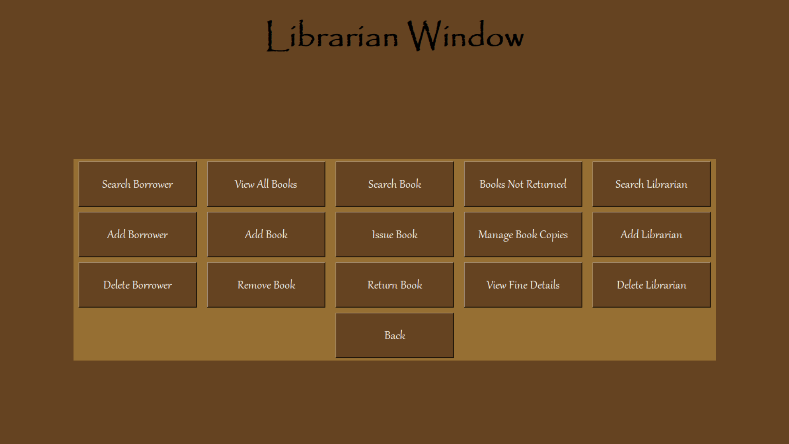

--------------------------------------------------------------------------------------------------------------------------

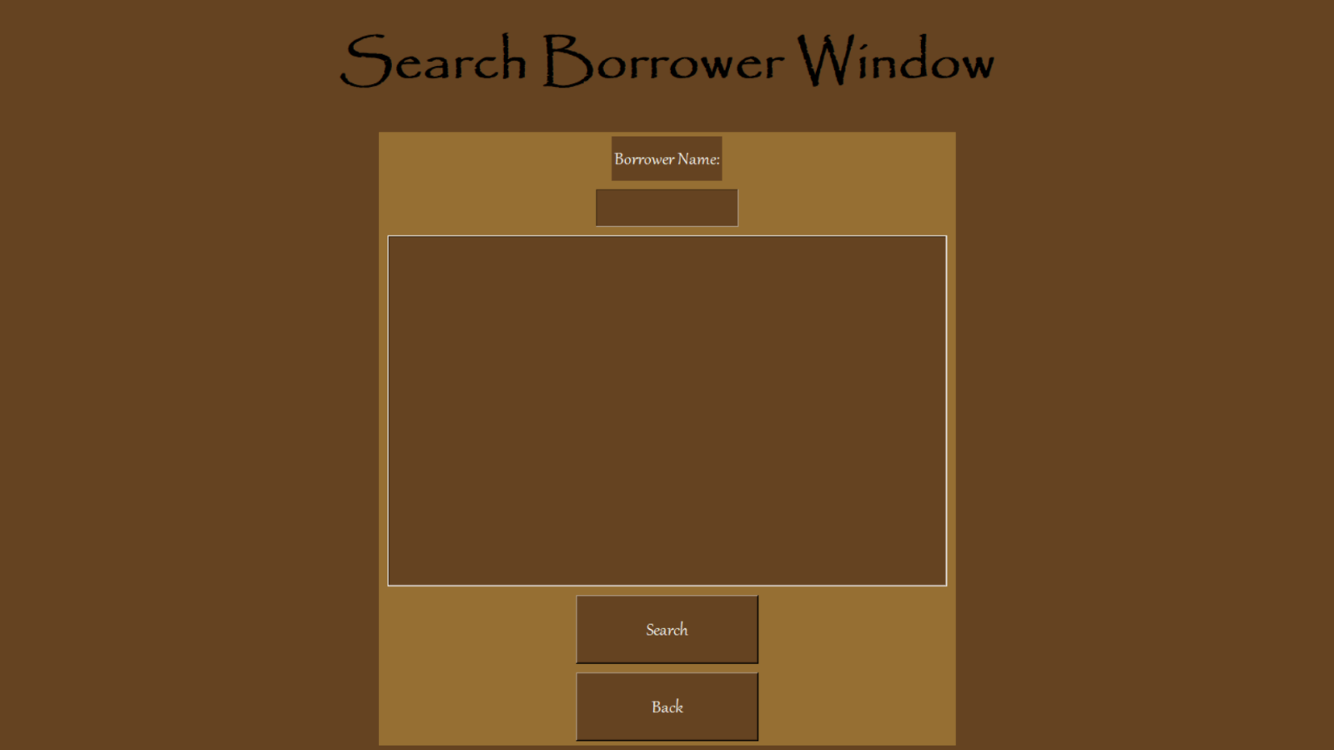

--------------------------------------------------------------------------------------------------------------------------

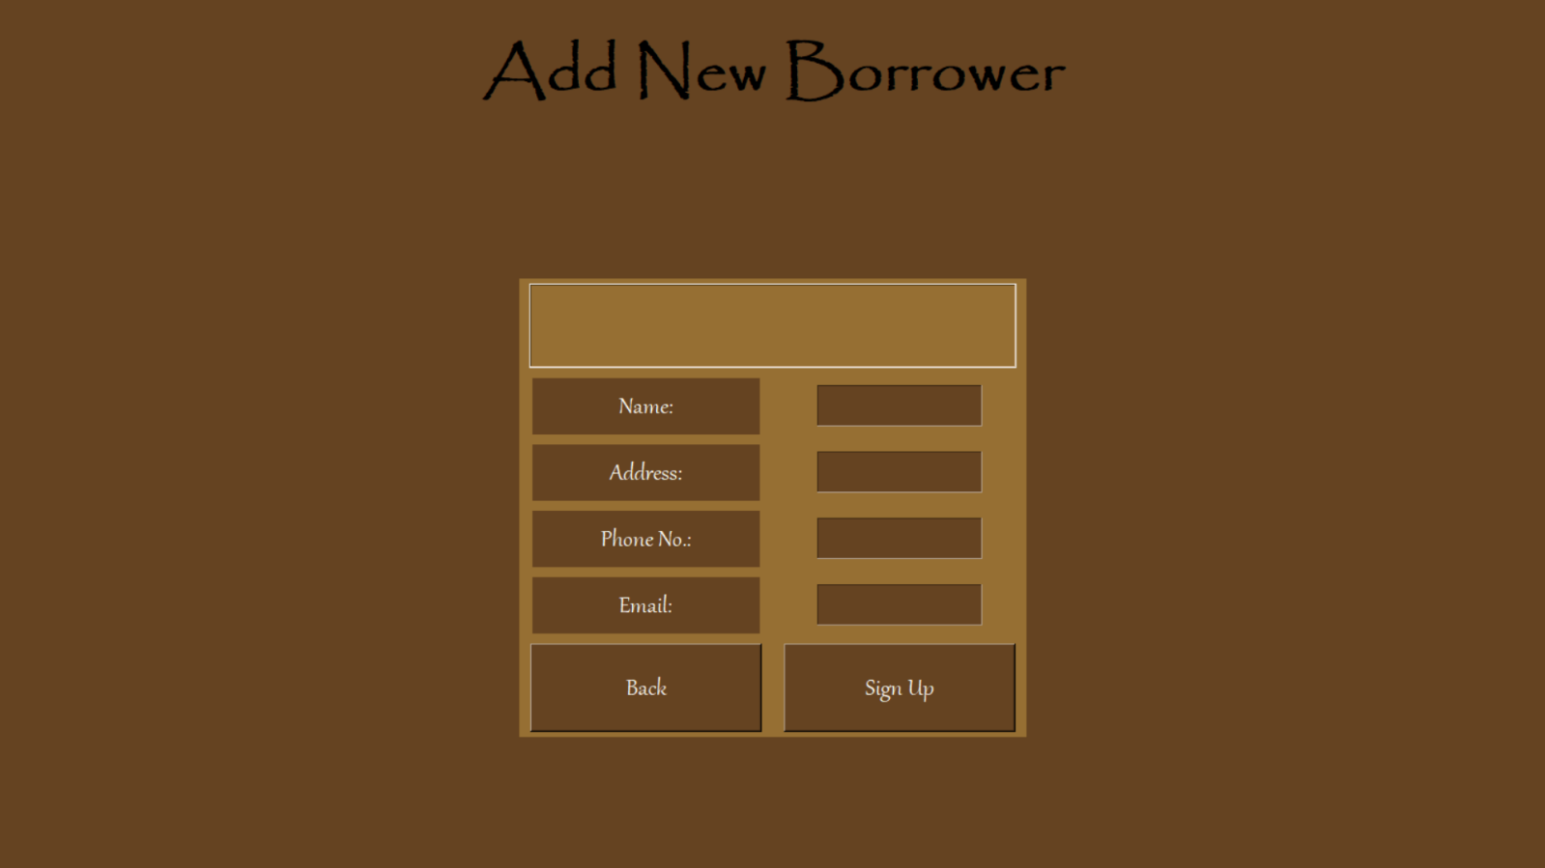

--------------------------------------------------------------------------------------------------------------------------

--------------------------------------------------------------------------------------------------------------------------

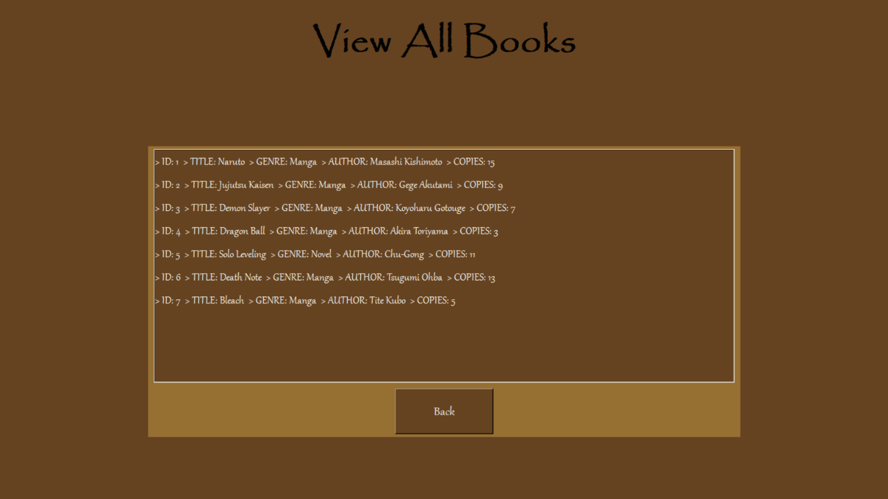

--------------------------------------------------------------------------------------------------------------------------

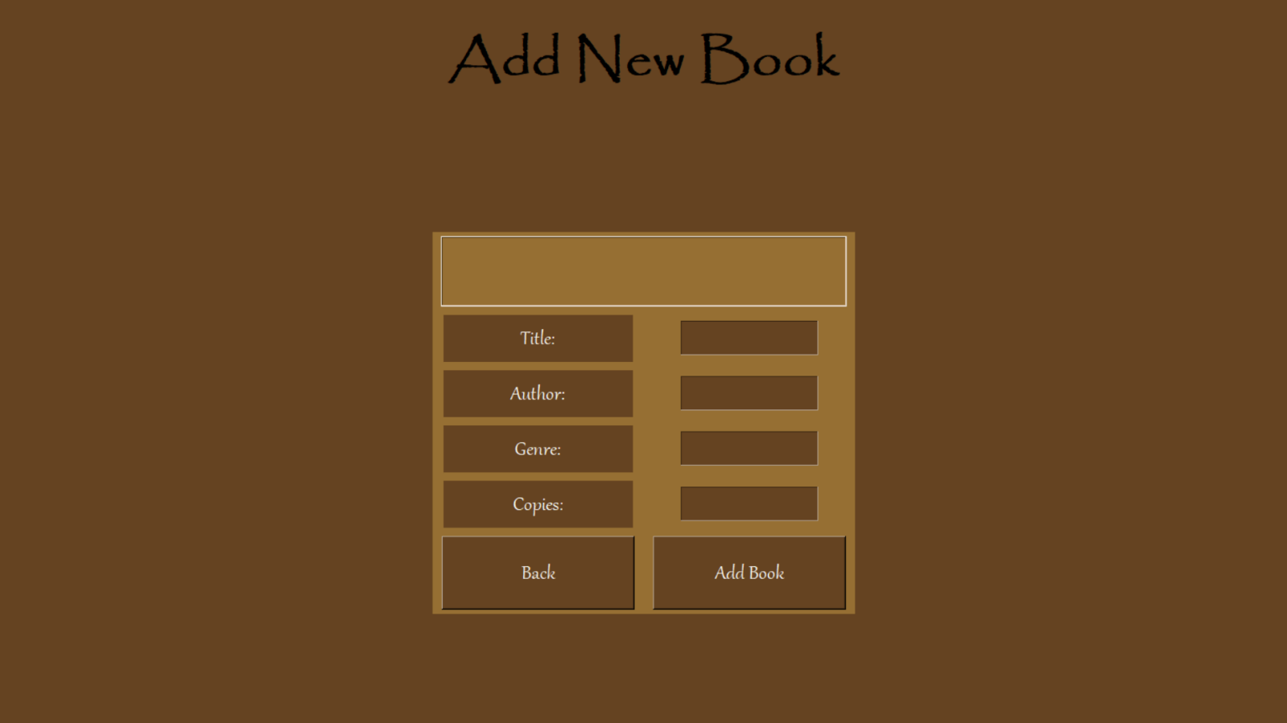

--------------------------------------------------------------------------------------------------------------------------

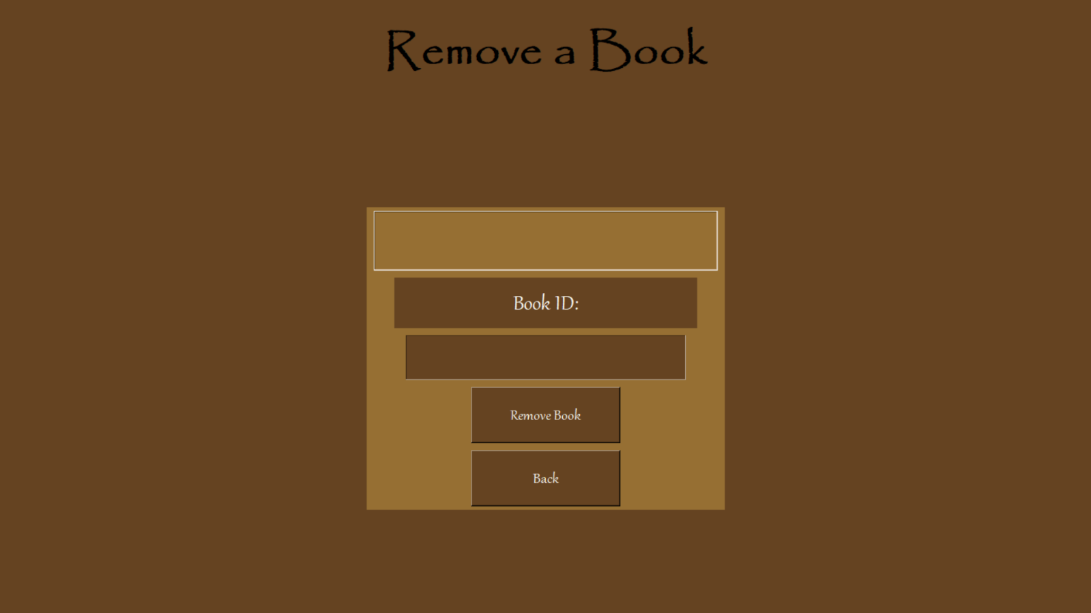

--------------------------------------------------------------------------------------------------------------------------

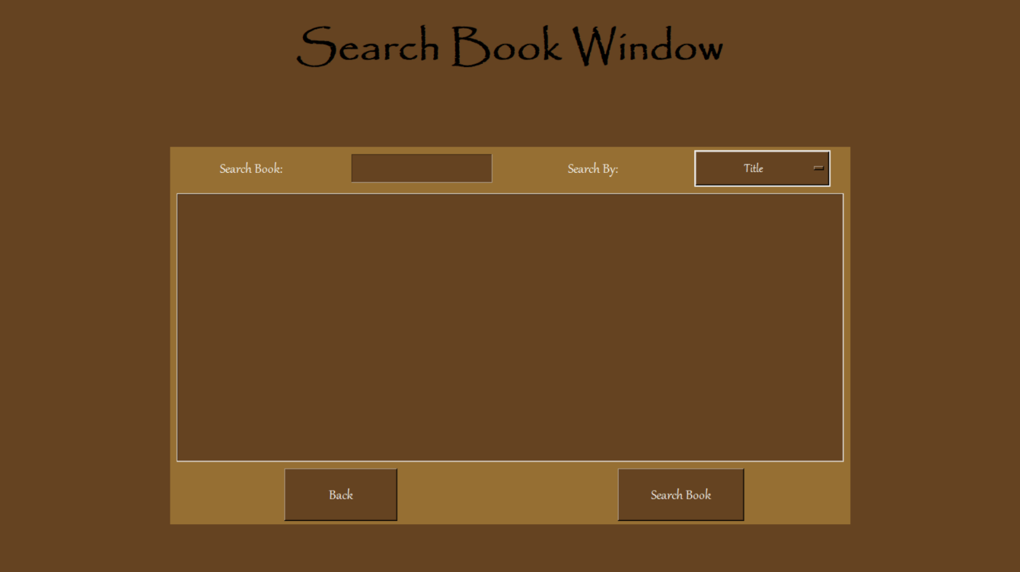

--------------------------------------------------------------------------------------------------------------------------

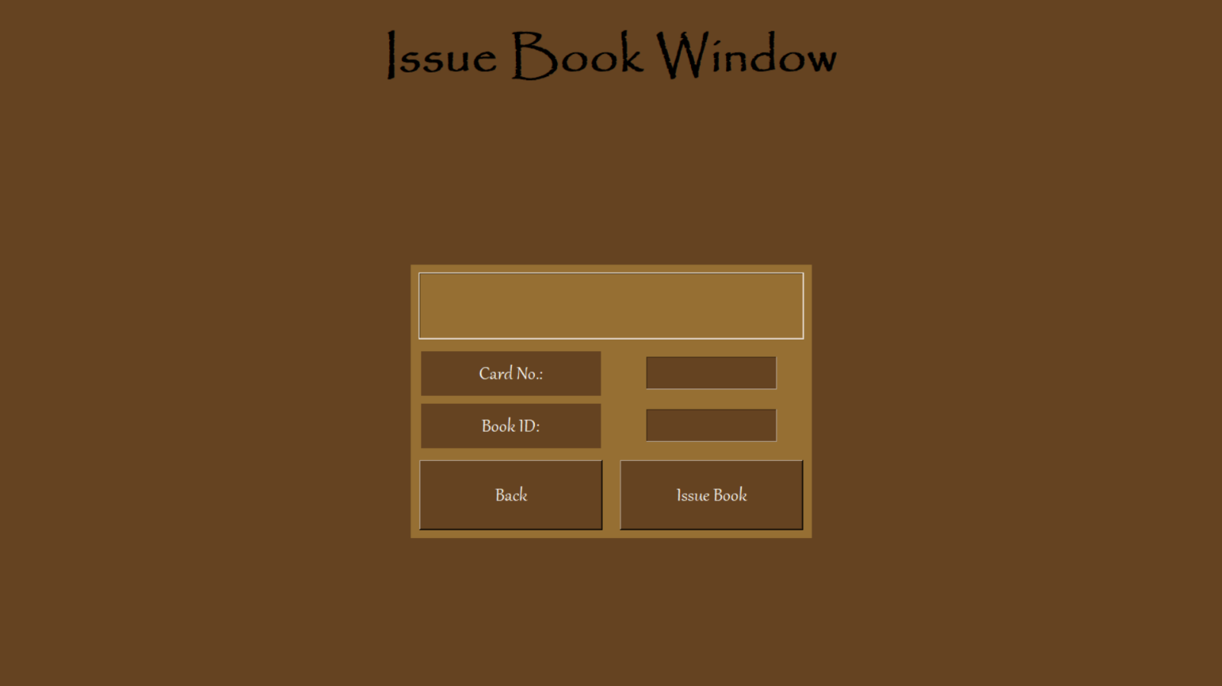

--------------------------------------------------------------------------------------------------------------------------

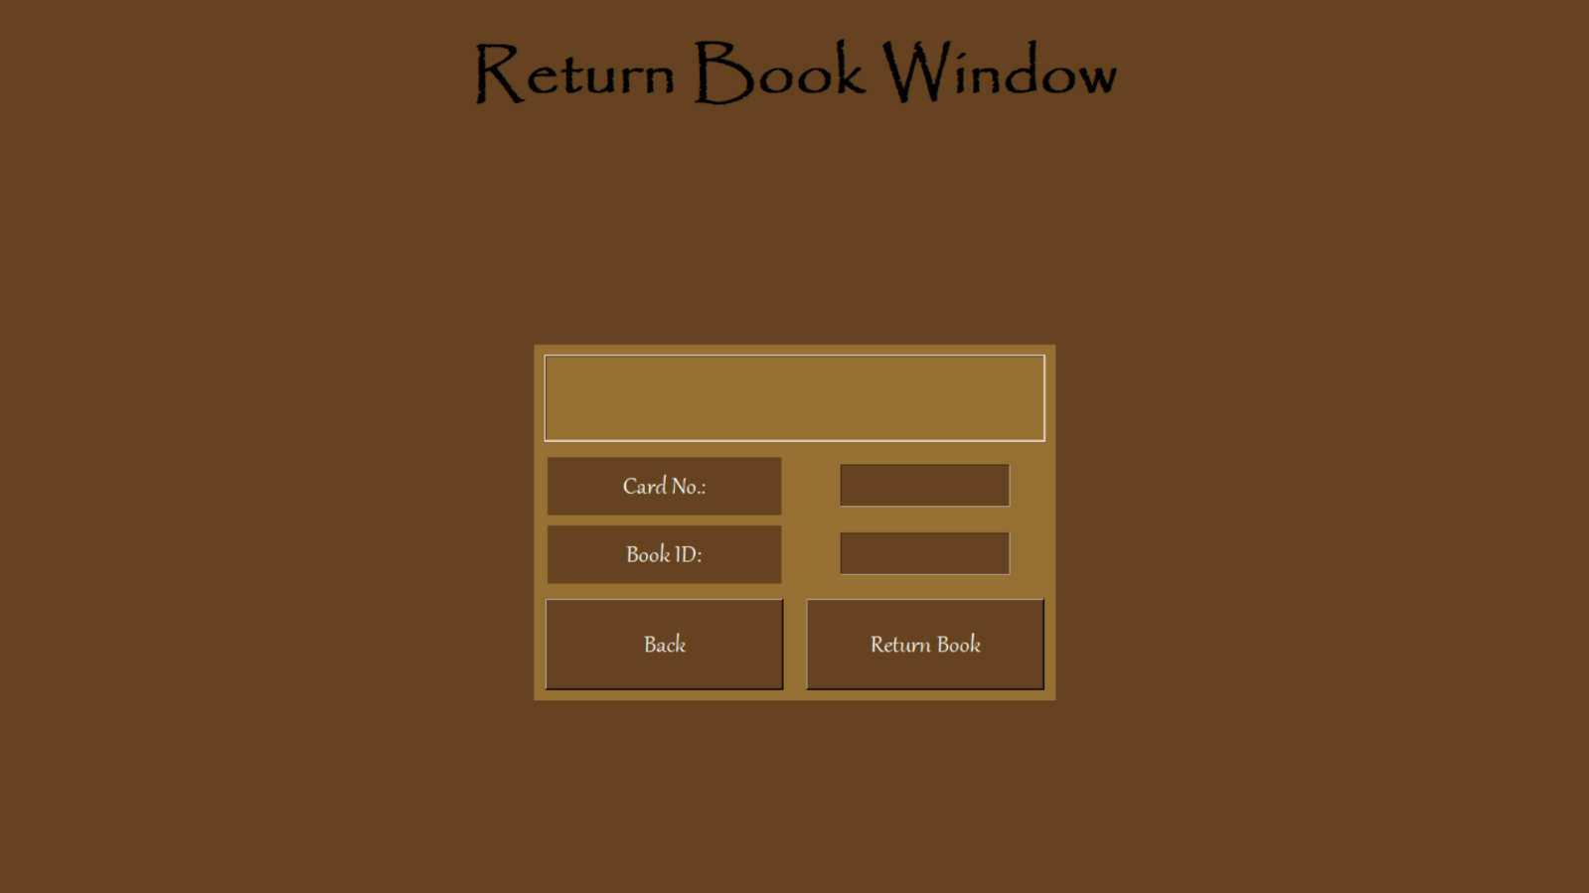

--------------------------------------------------------------------------------------------------------------------------

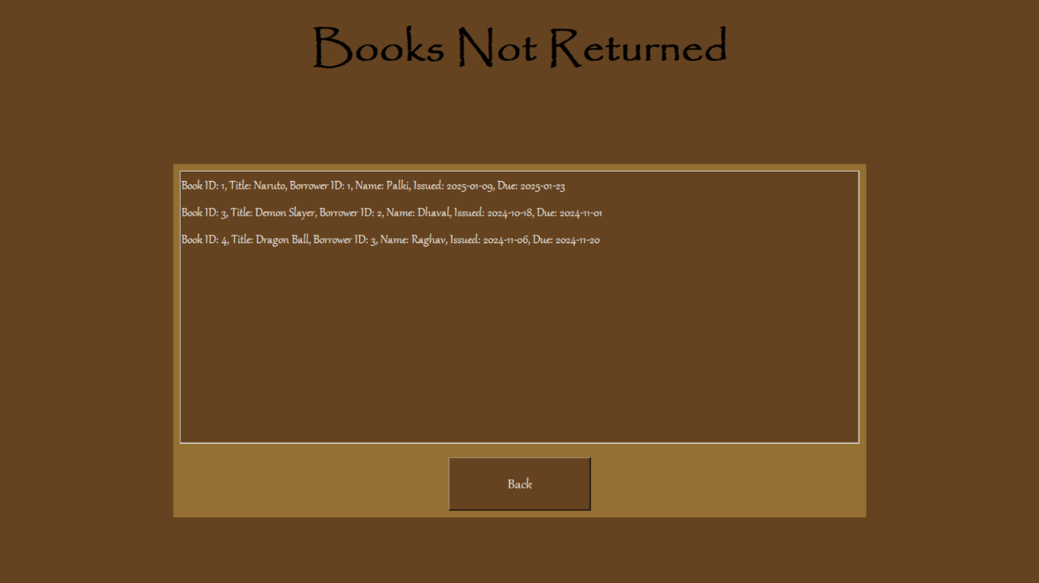

--------------------------------------------------------------------------------------------------------------------------

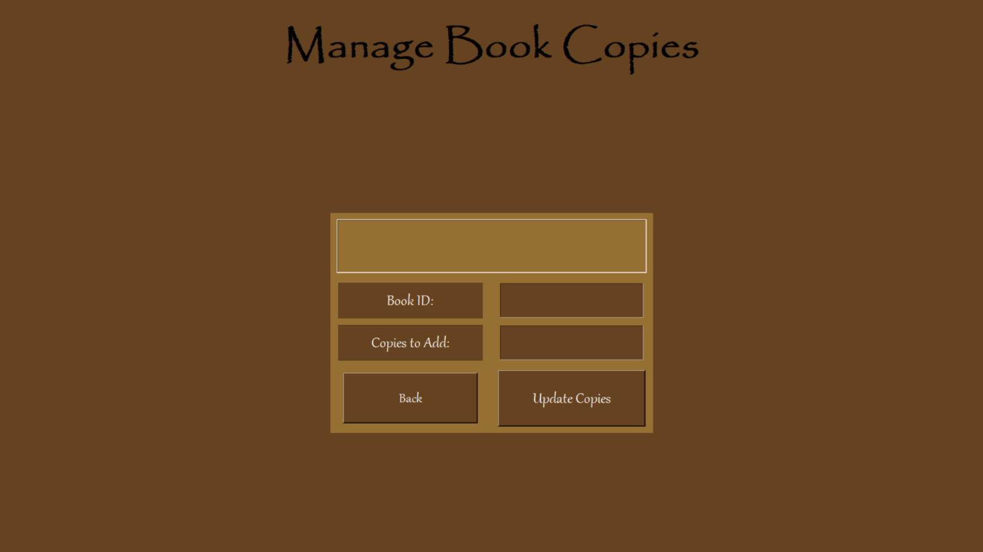

--------------------------------------------------------------------------------------------------------------------------

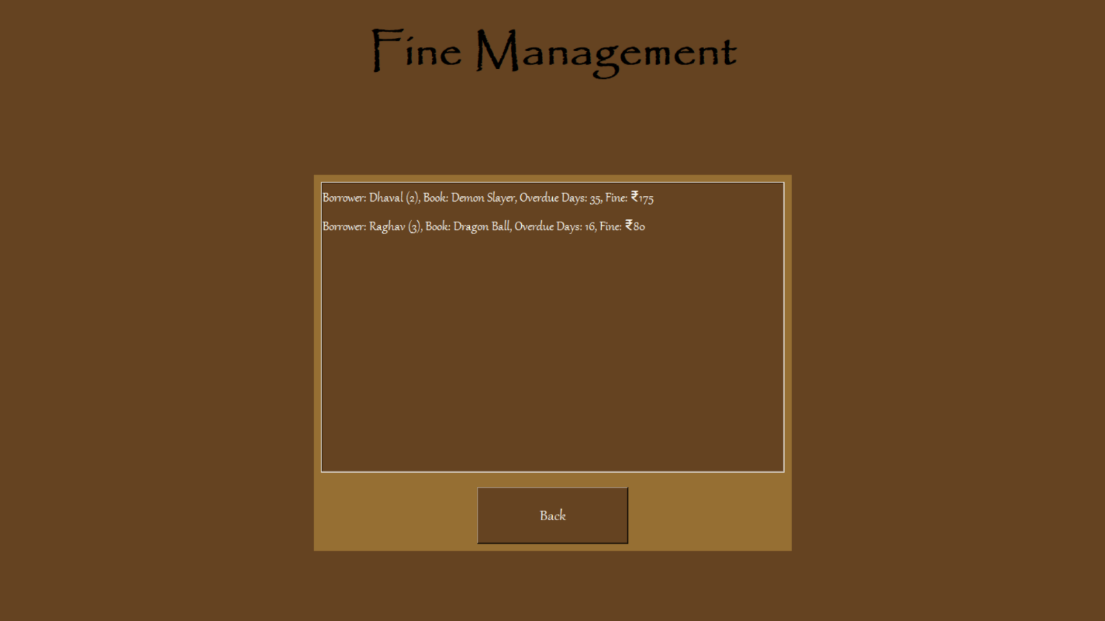

--------------------------------------------------------------------------------------------------------------------------

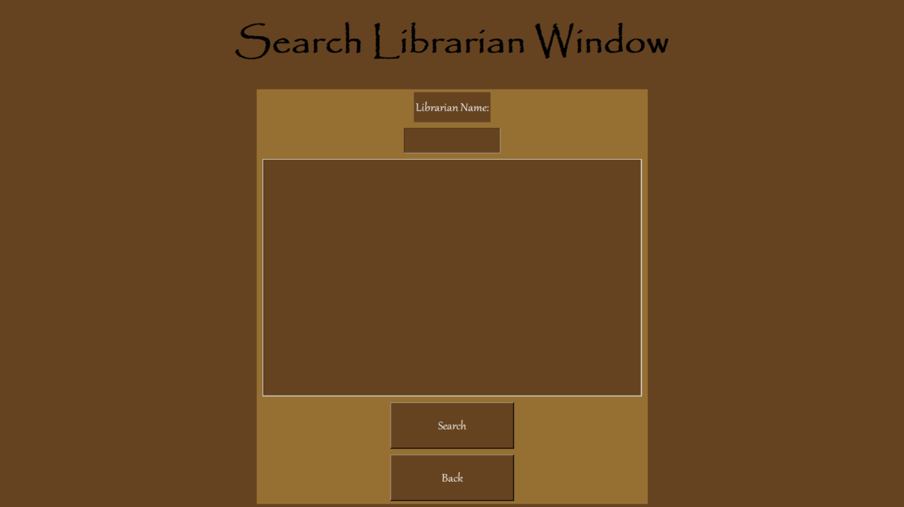

--------------------------------------------------------------------------------------------------------------------------

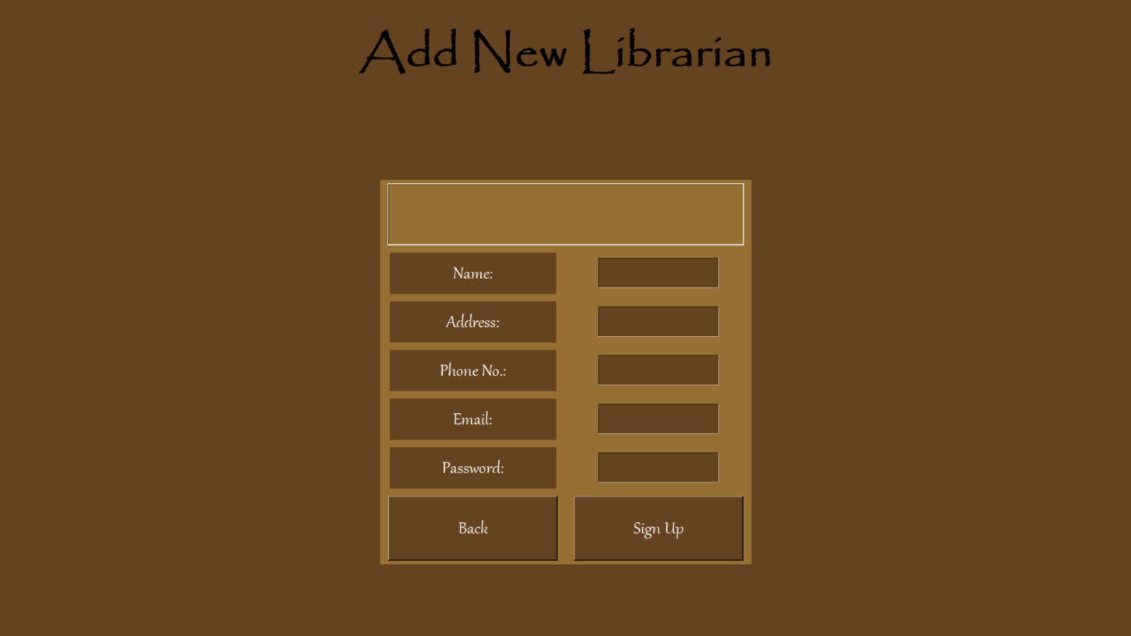

--------------------------------------------------------------------------------------------------------------------------

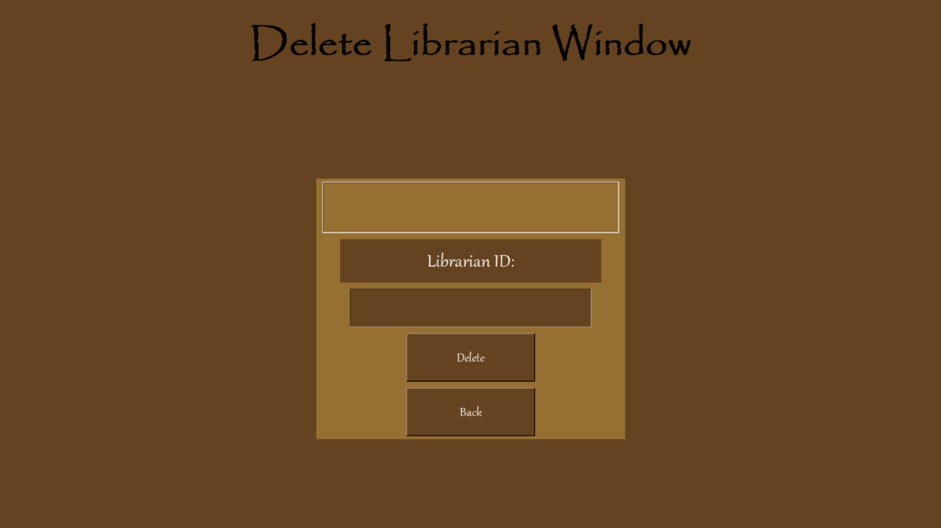

REFERENCES

* BIBLIOGRAPHY
  + Informatics Practices (Sumita Arora)
  + Informatics Practices (N.C.E.R.T.)
* WEBLIOGRAPHY
  + Chat GPT
  + Wikipedia